**What is the difference b/w Product Life Cycle and Project Life Cycle?**

Answer.

Product Life Cycle

The product life cycle represents the amount of revenue a product generates over time, from its inception to the point where it is discontinued. The five stages of a product's life are 1) development 2) introduction 3) growth, 4) maturity 5) decline

In the development stage, the product isn't yet being sold, so there is no revenue. During introduction, sales are small as people begin to try the product. Sales will increase during the growth phase, peak during maturity, and eventually decline as the market shifts or better alternatives become available. There is no set time span for a given stage; the entire cycle may last only months or a product like the refrigerator may remain in the maturity phase for decades.

Project Life Cycle

A project life cycle measures the work that goes into a project from beginning to end. The phases in product life cycle are 1) initiation 2) planning 3) Execution 4) Closure

During initiation, a business case and goals are created, and resources are assigned. During planning, the team researches solutions to reach the project goals and creates a plan and timeline to complete the project. Execution involves following each step on the project plan and adjusting as necessary along the way. Finally, in the closure phase, the project's final details are wrapped up and deliverable items like final reports are given to the appropriate parties.

**Q. Describe the following:-**

**1-VISION AND SCOPE DOCUMENTPROBLEM STATEMENT**

**2-MANAGEMENT SPECTRUM 4P’s in Project Management Spectrum**

**3-DECISION PROCESS**

Answer. 1-VISION AND SCOPE DOCUMENT PROBLEM STATEMENT

a) Project background-This Section contains a summary of the problem that the project wills solve.

b) Stakeholders-this is the bulleted list of stakeholders. Each stakeholder may be referred to by name or by title.

c) Users- this is the bulleted list of users. Each stakeholder may be referred to by name or by title.

d) Risks-this section list any potential risk to the project.

e) Assumptions-This list of assumptions that the stakeholders, users or project team have made. Vision of the solution that is

a) vision statement

b) list of features

C) scope of phased released

**2-MANAGEMENT SPECTRUM 4P’s in Project Management Spectrum**

* People
* Product
* Process
* Project

**PEOPLE**

* the most important factor in success of software project.
* “Companies That sensibly manage their investment in people will prosper in the long run” .
* Cultivation of motivated and highly skilled software people has always been important for software organizations. The “people-factor” is so important that has developed People Management Capability Maturity Model (PM-CMM)

**PRODUCT**

* The product and the problem it is intended to solve must be examined at very beginning of the software project.
* The scope of product must be established and bounded.
  + Bounded scope means :
    - Establishing quantitative data like no. of simultaneous users, max. allowable response time. etc.

**PROCESS**

* These characterize a software process and are applicable to all software projects
  + Communication
  + Planning
  + Modeling
  + Construction
  + Deployment
    - These are applied to software engineering work tasks (e.g., different product functions)

**PROJECT**

* + - Software people don’t understand customer needs
    - Product scope is poorly defined
    - Changes are managed poorly
    - The chosen technology changes
    - Business needs change
    - Deadlines are unrealistic

**3-DECISION PROCESS**

Decision making can be regarded as the mental processes resulting in the selection of a course of action among several alternative scenarios. Every decision making process produces a final choice. The output can be an action or an opinion of choice.

Objectives must first be established

♣ Objectives must be classified and placed in order of importance

♣ Alternative actions must be developed

♣ The alternative must be evaluated against all the objectives

♣ The alternative that is able to achieve all the objectives is the tentative decision

♣ The tentative decision is evaluated for more possible consequences

♣ The decisive actions are taken, and additional actions are taken to prevent any adverse consequences from becoming problems and starting both systems (problem analysis and decision making) all over again

♣ There are steps that are generally followed that result in a decision model that can be used to determine an optimal production plan.

♣ In a situation featuring conflict, role-playing is helpful for predicting decisions to be made by involved parties.

**What do you understand by software project planning? What are the various software planning activities? Also discuss various types software project planning.**

Software Project Planning involves developing estimates for the work to be performed, establishing the necessary commitments, and defining the plan to perform the work. Iterating through these steps may be necessary to establish the plan for the software project (i.e., the software development plan).

* Software Project Planning is Software project management process which is begins with *project planning*
* objective of software project planning is to provide a framework for manager to make reasonable *estimates of resources, costs and schedules*

So, the various activities of software planning are:

1. Software scope
2. resources
3. project estimation
4. decomposition
5. software scope

**Software Scope want to establish a project scope that is unambiguous and understandable at management and technical levels that describes:**

* 1. **function**
  2. **performance**
  3. **constraints**
  4. **interfaces**
  5. **reliability**

1. **Resources**

**It must estimate resources required to accomplish the development effort.**

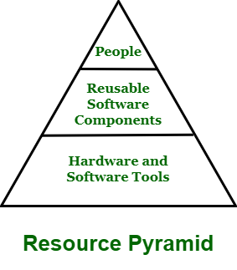

When software planner wants to specify resources, they specify it using four characteristics :

* Description of resource
* Resource availability
* Time of resource when it will be available
* Duration of resource availability

1. **Project estimation**

**cost estimates must be provided up frontbut... the longer we wait, the more we know, and the better our estimates.**

**use of decomposition techniques, empirical estimation models,**

**What you understand by work break structure (WBS)? What are the various types of WBS? Explain the benefits of WBS.**

A work-breakdown structure (WBS) in project management and systems engineering, is a deliverable-oriented breakdown of a project into smaller components. A work breakdown structure is a key project deliverable that organizes the team's work into manageable sections.

There are various types of WBS:

The Project Management Institute (PMI) Project Management Book of Knowledge (PMBOK) defines the Work Breakdown Structure as a “deliverable oriented hierarchical decomposition of the work to be executed by the project team.” There are two types of WBS:

1) Deliverable-Based/Product based: Entity Oriented like Financial engine, interface system, Database, typically used by engineering manager.

2) Phase-Based./Process WBS: Activity oriented like: Requirements, Analysis, Design, Testing and Implementation etc.

Some of the benefits of work breakdown structure training are that you can:

* Produce a WBS that is complete and accurate. This reduces risk by decreasing the likelihood that important work is missed.
* Accurately subdivide the project into smaller work packages. This has dual benefits of making tasks easier for project members to manage and allowing key milestones to be identified.
* Use the most beneficial layout depending on whether you are developing, communicating or presenting your WBS.
* Engage project members in the development of the WBS.  Involving project teams and expert resources in creating the detailed steps of the WBS encourages discussions that: 1) clarify uncertainties and ambiguities, 2) identify assumptions-both correct and incorrect, 3) narrow and define the project scope, and 4) raise important issues at an early stage. Seeking high levels of participation to prepare the WBS produces well-defined tasks, allows resources to be assigned to specific tasks, and creates accountability and commitment among the project team.

**Q. Discuss capability maturity model Answer.**

The Capability Maturity Model (CMM) is a theoretical process capability maturity model. The CMM was originally developed as a tool for objectively assessing the ability of government contractors ‘processes to perform a contracted software project. For this reason, it has been used extensively for avionics software and government projects around the world.

The 5-Level structure of the CMM can be illustrated by the diagram below (Figure 1).

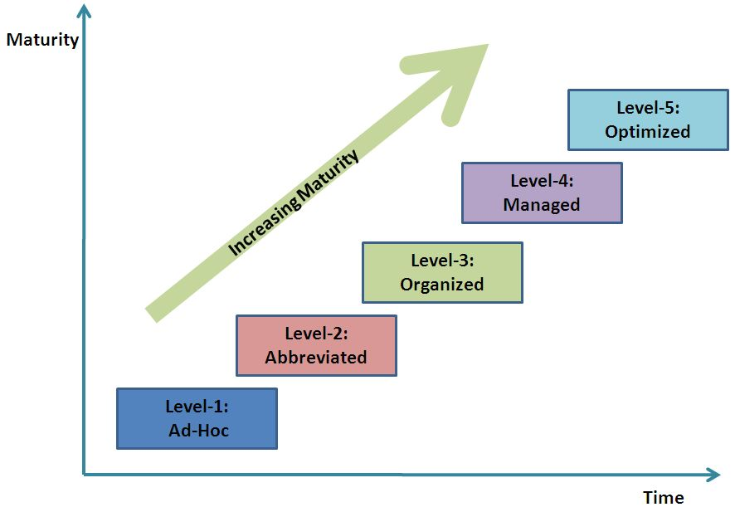

Define Process

Figure 1: Diagram of the CMM

Although the CMM comes from the area of software development, it can be (and has been and still is being) applied as a generally applicable model to assist in understanding the process capability maturity of organization in areas as diverse as, for example: software engineering, system engineering, project management, software maintenance, risk management, system acquisition, information technology (IT), and personnel management.

Structure of the CMM

The CMM involves the following aspects:

• Maturity Levels: A 5-Level process maturity continuum - where the uppermost (5th) level is a notional ideal state where processes would be systematically managed by a combination of process optimization and continuous process improvement.

• Key Process Areas: Within each of these maturity levels are Key Process Areas (KPAs) which characterize that level, and for each KPA there are five definitions identified:

o Goals o Commitment

o Ability

o Measurement

o Verification

The KPAs are not necessarily unique to CMM, representing - as they do - the stages that organizations’ processes will need to pass through as they progress up the CMM continuum.

• Goals: The goals of a key process area summarize the states that must exist for that key process area to have been implemented in an effective and lasting way. The extent to which the goals have been accomplished is an indicator of how much capability the organization has established at that maturity level. The goals signify the scope, boundaries, and intent of each key process area.

• Common Features: Common features include practices that implement and institutionalize a key process area. There are five types of common features: Commitment to Perform, Ability to Perform, Activities Performed, Measurement and Analysis, and Verifying Implementation.

• Key Practices: The key practices describe the elements of infrastructure and practice that contribute most effectively to the implementation and institutionalization of the KPAs.

**Levels of the CMM**

* At the initial level, processes are disorganized, even chaotic. Success is likely to depend on individual efforts, and is not considered to be repeatable, because processes would not be sufficiently defined and documented to allow them to be replicated.
* At the repeatable level, basic project management techniques are established, and successes could be repeated, because the requisite processes would have been made established, defined, and documented.
* At the defined level, an organization has developed its own standard software process through greater attention to documentation, standardization, and integration.
* At the managed level, an organization monitors and controls its own processes through data collection and analysis.
* At the optimizing level, processes are constantly being improved through monitoring feedback from current processes and introducing innovative processes to better serve the organization's particular needs.

**Question: SOFTWARE QUALITY ASSURANCE IS AN UMBRELLA ACTIVITY**

**Answer**

quality assurance is an umbrella activity that is applied throughout the software process.

SQA encompasses:

(1) a quality management approach

(2) effective software engineering technology

(3) formal technical reviews

(4) a multi-tiered testing strategy

(5) document change control

(6) software development standard and its control procedure

(7) measurement and reporting mechanism

Quality --> refers to measurable characteristics of a software. These items can be compared based on a given standard

Two types of quality control: -

Quality design -> the characteristics that designers specify for an item.

--> includes: requirements, specifications, and the design of the system.

- Quality of conformance -> the degree to which the design specification are followed. It focuses on implementation based on the design.